**VI Editor in Linux:**

The VI editor is the most popular and commonly used editor on Linux. It is available in all Linux distributions. Currently we use VIM i.e. **V**i **Im**proved. Some of the other ones are Elvis, Nvi, Nano, and Vile. It is wise to learn vi because it is feature-rich and offers endless possibilities to edit a file.

VI editor commands are as follows:

**Starting the vi Editor:**

There are following way you can start using vi editor:

* **vi filename:** Creates a new file if it already not exists, otherwise opens existing file.
* **vi -R filename:** Opens an existing file in read only mode.
* **view filename**: Opens an existing file in read only mode.

**Moving within a File (Navigation):**

To move around within a file without affecting text must be in command mode (press Esc twice). Here are some of the commands can be used to move around one character at a time.

* **k**: Moves the cursor up one line.
* **j:**  Moves the cursor down one line.
* **h**: Moves the cursor to the left one-character position.
* **l:**  Moves the cursor to the right one-character position.
* **0 or |**: Positions cursor at beginning of line.
* **$:**  Positions cursor at end of line.
* **W:**  Positions cursor to the next word.
* **B:**  Positions cursor to previous word.
* **(:**  Positions cursor to beginning of current sentence.
* **)**: Positions cursor to beginning of next sentence.
* **H:**  Move to top of screen.
* **nH:**  Moves to nth line from the top of the screen.
* **M:**  Move to middle of screen.
* **L:**  Move to bottom of screen.
* **nL:**  Moves to nth line from the bottom of the screen.
* **colon along with x:**  Colon followed by a number would position the cursor on line number represented by x.

**Control Commands (Scrolling):**

There are following useful commands which can used along with **Control Key**:

* **CTRL+d:**  Move forward 1/2 screen.
* **CTRL+f:**  Move forward one full screen.
* **CTRL+u**: Move backward 1/2 screen.
* **CTRL+b:**  Move backward one full screen.
* **CTRL+e**: Moves screen up one line.
* **CTRL+y**: Moves screen down one line.
* **CTRL+u:**  Moves screen up 1/2 page.
* **CTRL+d**: Moves screen down 1/2 page.
* **CTRL+b**: Moves screen up one page.
* **CTRL+f**: Moves screen down one page.
* **CTRL+I**: Redraws screen.

**Editing and inserting in Files (Entering and Replacing Text):**

To edit the file, we need to be in the insert mode. There are many ways to enter insert mode from the command mode.

* **I**: Inserts text before current cursor location.
* **I:**  Inserts text at beginning of current line.
* **A:**  Inserts text after current cursor location.
* **R:**  Replaces text from the cursor to right.
* **S:**  Replaces single character under the cursor with any number of characters.
* **S**: Replaces entire line.

**Deleting Characters:**

Here is the list of important commands which can be used to delete characters and lines in an opened file.

* **X:**  Deletes the character under the cursor location.
* **X:**  Deletes the character before the cursor location.
* **Dw**: Deletes from the current cursor location to the next word.
* **d^**: Deletes from current cursor position to the beginning of the line.
* **d$**: Deletes from current cursor position to the end of the line.
* **Dd**: Deletes the line the cursor is on.

**Copy and Paste Commands:**

Copy lines or words from one place and paste them on another place by using the following commands.

* **Yy:**  Copies the current line.
* **9yy**: Yank current line and 9 lines below.
* **p:**  Puts the copied text after the cursor.
* **P:**  Puts the yanked text before the cursor.

**Save and Exit Commands of the ex Mode :**

Need to press **[Esc]** key followed by the colon (:) before typing the following commands:

* **q:**  Quit
* **q!**: Quit without saving changes i.e. discard changes.
* **r fileName**: Read data from file called fileName.
* **wq:**  Write and quit (save and exit).
* **w fileName**: Write to file called fileName (save as).
* **w! fileName**: Overwrite to file called fileName (save as forcefully).
* **!cmd:**  Runs shell commands and returns to Command mode.

**Sick Application in VI Editor:**

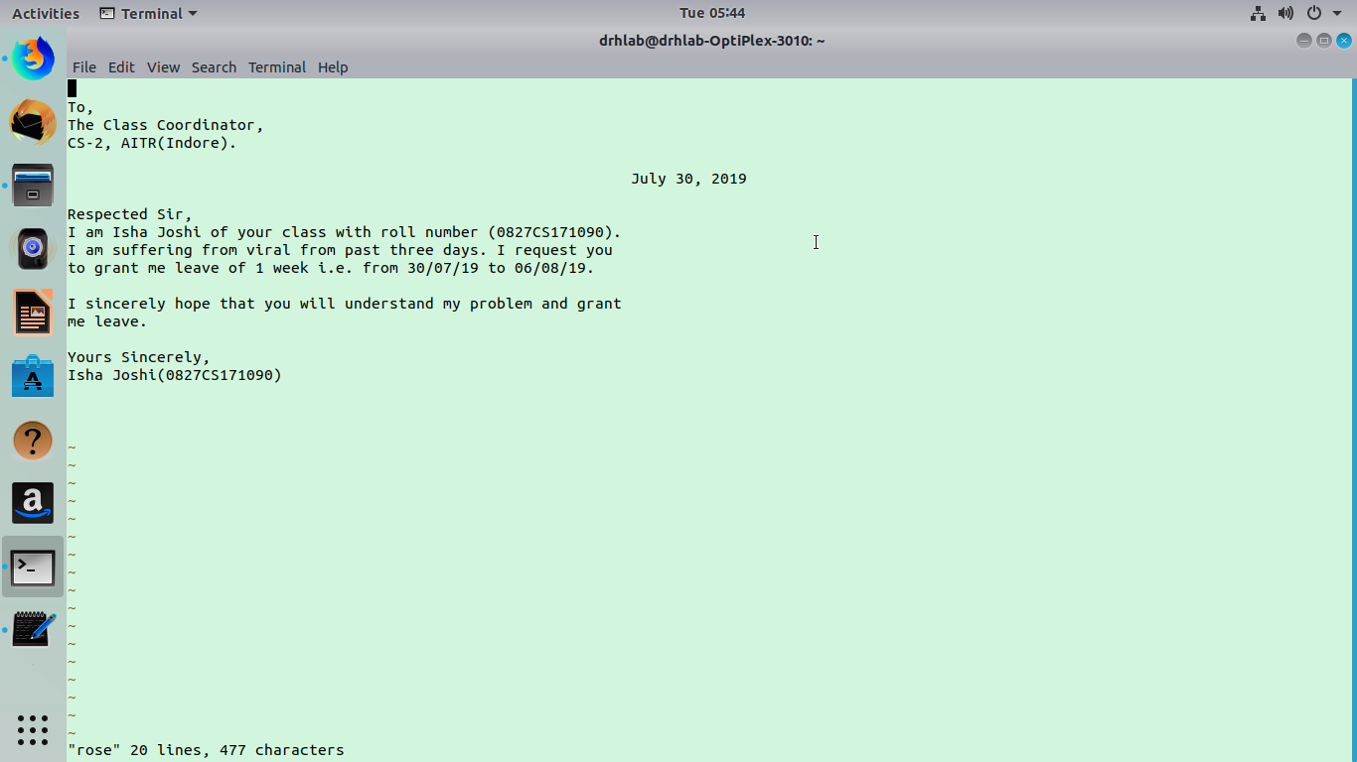

**Essay in VI Editor:**

